Table of Contents

I. Makati Police Office Wanted and Missing Database System 2

II. Glossary 2

IV. Event Table 5

V. Use Case 6

VI. Full Use Case Description 6

VII. Context Flow Diagram 9

VIII. Data Flow Diagram 10

IX. Entity Relationship Diagram 10

X. Data Dictionary 11

XI. UML Diagrams 15

XII. Design 21

# Makati Police Office Wanted and Missing Database System

**Client**: Makati Police Office

**Project Objective**

To create a database system for Makati Police Office to have an easier way of disseminating and organizing information regarding the wanted and missing people since the existing process is performed manually.  
  
**Target Users**

* Makati Police Officers
* Makati Citizens
* External Offices

**Project Description**

The Wanted and Missing Database System is a proposed project for Makati Police Office which will be used for posting information about wanted and missing people.

# Glossary

|  |  |
| --- | --- |
| Event Table | An event table is a table of data that is typically written to the log files for each scenario and also appears in the Analysis window. The event table contains timing information about specific events that occur during the scenario. |
| Use Case | A use case is a list of steps, typically defining interactions between a role (known in [Unified Modeling Language](http://en.wikipedia.org/wiki/Unified_Modeling_Language) (UML) as an "[actor](http://en.wikipedia.org/wiki/Actor_(UML))") and a system, to achieve a goal. The actor can be a human, an external system, or time. |
| Activity Diagram | Activity diagrams are graphical representations of [workflows](http://en.wikipedia.org/wiki/Workflow) of stepwise activities and actions with support for choice, iteration and concurrency. Activity diagrams are constructed from a limited number of shapes, connected with arrows. |
| Context Flow Diagram | A Context Flow Diagram, which is also called System Context Diagram (SCD) in [software engineering](http://en.wikipedia.org/wiki/Software_engineering) and [systems engineering](http://en.wikipedia.org/wiki/Systems_engineering) is a [diagram](http://en.wikipedia.org/wiki/Diagram) that defines the boundary between the [system](http://en.wikipedia.org/wiki/System), or part of a system, and its environment, showing the entities that interact with it. This diagram is a high level view of a [system](http://en.wikipedia.org/wiki/System). |
| Data Flow Diagram | A data flow diagram (DFD) is a graphical representation of the "flow" of data through an [information system](http://en.wikipedia.org/wiki/Information_system), modeling its process aspects. Often they are a preliminary step used to create an overview of the system which can later be elaborated. |
| Entity Relationship Diagram | An entity-relationship (ER) diagram is a specialized graphic that illustrates the [relationships between entities in a database](http://databases.about.com/od/specificproducts/a/Database-Relationships-An-Introduction-To-Foreign-Keys-Joins-And-E-R-Diagrams.htm). |
| Data Dictionary | A data dictionary, or [metadata](http://en.wikipedia.org/wiki/Metadata) [repository](http://en.wikipedia.org/wiki/Software_repository), is a centralized repository of information about data such as meaning, relationships to other data, origin, usage, and format. |
| Activity Diagram | Depicts high-level business processes, including data flow, or to model the logic of complex logic within a system. |
| Class Diagram | Shows a collection of static model elements such as classes and types, their contents, and their relationships. |
| Communication Diagram | Shows instances of classes, their interrelationships, and the message flow between them. Communication diagrams typically focus on the structural organization of objects that send and receive messages. |
| Component Diagram | Depicts the components that compose an application, system, or enterprise. The components, their interrelationships, interactions, and their public interfaces are depicted. |
| Composite Structure Diagram | Depicts the internal structure of a classifier (such as a class, component, or use case), including the interaction points of the classifier to other parts of the system. |
| Deployment Diagram | Shows the execution architecture of systems. This includes nodes, either hardware or software execution environments, as well as the middleware connecting them. |
| Interaction Overview Diagram | A variant of an activity diagram which overviews the control flow within a system or business process. Each node/activity within the diagram can represent another interaction diagram. |
| Object Diagram | Depicts objects and their relationships at a point in time, typically a special case of either a class diagram or a communication diagram. - |
| Package Diagram | Shows how model elements are organized into packages as well as the dependencies between packages. |
| Sequence Diagram | Models the sequential logic, in effect the time ordering of messages between classifiers. |
| State Machine Diagram | Describes the states an object or interaction may be in, as well as the transitions between states. Formerly referred to as a state diagram, state chart diagram, or a state-transition diagram. |
| Timing Diagram | Depicts the change in state or condition of a classifier instance or role over time. Typically used to show the change in state of an object over time in response to external events. |
| Use Case Diagram | Shows use cases, actors, and their interrelationships. |

# Event Table

**COURT**

|  |  |  |  |  |  |
| --- | --- | --- | --- | --- | --- |
| Event | Trigger | Source | Use Case | Response | Destination |
| Court issues arrest warrant | Arrest warrant request | Court | Issue arrest warrant | Arrest warrant | MPO |

**MPO**

|  |  |  |  |  |  |
| --- | --- | --- | --- | --- | --- |
| Event | Trigger | Source | Use Case | Response | Destination |
| MPO requests for arrest warrant | Wanted person | MPO | Request for arrest warrant | Arrest warrant request | Court |
| MPO creates wanted/missing person record | Arrest warrant/Missing person report | MPO | Create wanted/missing record | Wanted/missing person record | System |
| MPO posts wanted/missing person record | Wanted/missing person record | MPO | Post wanted/missing person record | Wanted/missing person post | System |
| MPO searches for wanted/missing person record | Wanted/missing person record request | MPO | Search for wanted/missing person record | Wanted/missing person record | System |
| MPO captures/finds wanted/missing person | Wanted/missing person | MPO | Capture/find wanted/missing person | Wanted/missing person captured/found | MPO |
| MPO updates wanted/missing person record | Wanted/missing person found | MPO | Update wanted/missing person record | Updated wanted/missing person record | System |

**CITIZEN**

|  |  |  |  |  |  |
| --- | --- | --- | --- | --- | --- |
| Event | Trigger | Source | Use Case | Response | Destination |
| Citizen files a missing person report | Missing person | Citizen | File a missing person repost | Missing person report | MPO |
| Citizen requests for wanted/missing person record | Citizen request | Citizen | Request for a wanted/missing person record | Wanted/missing person record request | MPO |

# Use Case

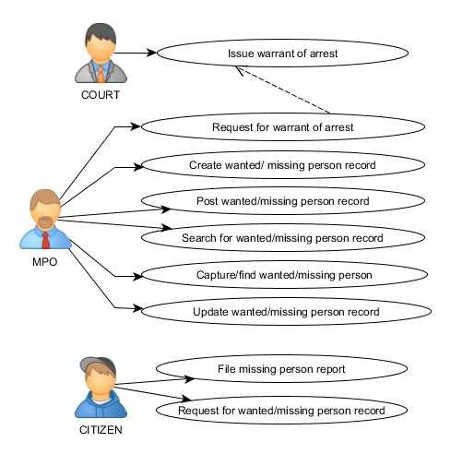

# Full Use Case Description

|  |  |  |
| --- | --- | --- |
| Use Case: | Request for arrest warrant | |
| Related Use Case: | N/A | |
| Triggering Event: | There is a wanted person | |
| Brief Description: | MPO requests an arrest warrant | |
| Actor: | MPO | |
| Pre-condition: | Wanted person must exist | |
| Post-condition: | Court will be notified about the arrest warrant | |
| Flow of activities: | Actor   1. MPO requests for an arrest warrant | System   1. N/A |
| Exception condition: | If there is no wanted person | |

|  |  |  |
| --- | --- | --- |
| Use Case: | Issue warrant of arrest | |
| Related Use Case: | MPO requests for a warrant of arrest | |
| Triggering Event: | Arrest warrant issuance | |
| Brief Description: | Court issues warrant of arrest | |
| Actor: | Court | |
| Pre-condition: | Court must exist | |
| Post-condition: | Warrant of arrest will be handed to MPO | |
| Flow of activities: | Actor   1. Court issues warrant of arrest | System   1. N/A |
| Exception condition: | If there is no warrant of arrest | |

|  |  |  |
| --- | --- | --- |
| Use Case: | File report for a missing person | |
| Related Use Case: | N/A | |
| Triggering Event: | There is a missing person | |
| Brief Description: | Citizen files report for a missing person | |
| Actor: | Citizen | |
| Pre-condition: | Report must meet the requirements for considering a missing person | |
| Post-condition: | MPO will take action | |
| Flow of activities: | Actor   1. Citizen files report for a missing person 2. Citizen gives details of the missing person | System   1. N/A |
| Exception condition: | If report hasn’t meet the requirements | |

|  |  |  |
| --- | --- | --- |
| Use Case: | Create wanted/missing person record | |
| Related Use Case: | Court issues arrest warrant/Citizen files a missing person report | |
| Triggering Event: | MPO has received an arrest warrant/MPO receives a missing person report | |
| Brief Description: | MPO creates wanted/missing person record | |
| Actor: | MPO | |
| Pre-condition: | Arrest warrant must exist/Missing person report must exist | |
| Post-condition: | MPO, citizens, and external offices will be informed with the wanted/missing person information | |
| Flow of activities: | Actor   1. MPO creates wanted/missing person record in their log book | System   1. MPO creates wanted/missing person record in the system |
| Exception condition: | If there is no arrest warrant or missing person report | |

|  |  |  |
| --- | --- | --- |
| Use Case: | Post wanted/missing person record | |
| Related Use Case: | Create wanted/missing person record | |
| Triggering Event: | MPO has new wanted/missing person record | |
| Brief Description: | MPO posts wanted/missing person record | |
| Actor: | MPO | |
| Pre-condition: | New wanted/missing person record must exist | |
| Post-condition: | MPO, citizens, and external offices will be informed with the wanted information | |
| Flow of activities: | Actor   1. MPO posts wanted/missing person information to a bulletin board which can be seen by the citizens and external offices/MPO | System   1. MPO posts wanted/missing person record to the system |
| Exception condition: | If there is no new record | |

|  |  |  |
| --- | --- | --- |
| Use Case: | Request for a wanted/missing person record | |
| Related Use Case: | N/A | |
| Triggering Event: | Citizen request | |
| Brief Description: | Citizen requests for a wanted/missing person record | |
| Actor: | Citizen | |
| Pre-condition: | There must be a citizen | |
| Post-condition: | MPO will search for the record in the system | |
| Flow of activities: | Actor   1. Citizen requests for wanted/missing person record | System   1. N/A |
| Exception condition: | If there is no citizen | |

|  |  |  |
| --- | --- | --- |
| Use Case: | Search for a wanted/missing person record | |
| Related Use Case: | Request for a wanted/missing person record | |
| Triggering Event: | Citizen request | |
| Brief Description: | MPO searches for a wanted/missing person record | |
| Actor: | MPO | |
| Pre-condition: | There must be a wanted/missing person info | |
| Post-condition: | MPO will let the citizen see the record | |
| Flow of activities: | Actor   1. MPO searches for the wanted/missing person in their log book | System   1. MPO searches for wanted/missing person record in the system |
| Exception condition: | If there is no wanted/missing person info | |

|  |  |  |
| --- | --- | --- |
| Use Case: | Capture/find wanted/missing person | |
| Related Use Case: | N/A | |
| Triggering Event: | Wanted/missing person alarm | |
| Brief Description: | MPO captures/finds wanted/missing person | |
| Actor: | MPO | |
| Pre-condition: | Wanted/missing person must have been seen | |
| Post-condition: | Wanted/missing person must be captured/found | |
| Flow of activities: | Actor   1. MPO captures/finds wanted/missing person | System   1. N/A |
| Exception condition: | If wanted/missing person was failed to be captured/found | |

|  |  |  |
| --- | --- | --- |
| Use Case: | Update wanted/missing person record | |
| Related Use Case: | Capture/find wanted/missing person | |
| Triggering Event: | Wanted/missing person captured/found | |
| Brief Description: | MPO updates wanted/missing person record | |
| Actor: | MPO | |
| Pre-condition: | Wanted/missing person must be captured/found | |
| Post-condition: | The record will be updated | |
| Flow of activities: | Actor   1. MPO updates wanted/missing person post 2. MPO removes the post for the wanted/missing person found/captured | System   1. MPO updates wanted/missing person post in the system |
| Exception condition: | If wanted/missing person hasn’t been captured/found | |

# Context Flow Diagram

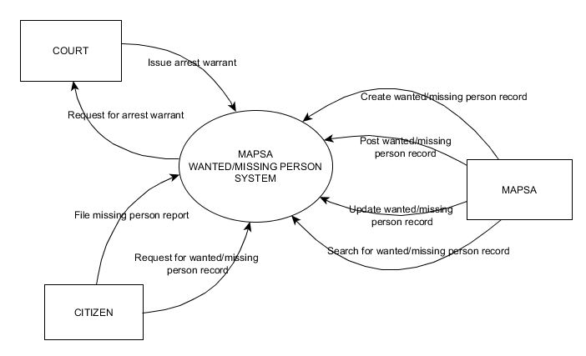

# Data Flow Diagram

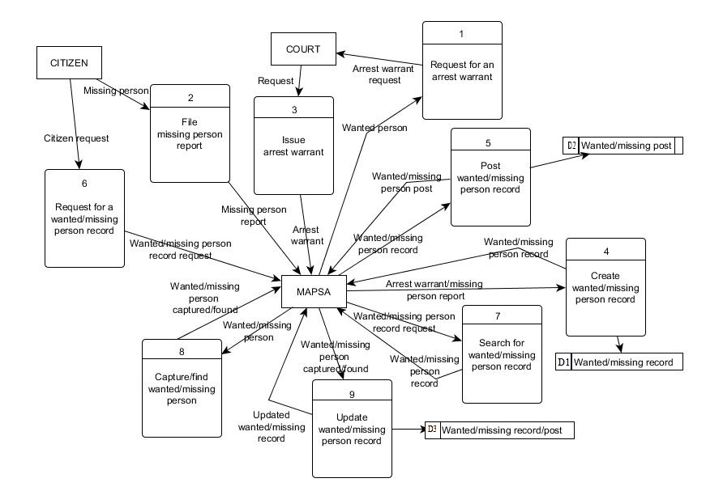

# Entity Relationship Diagram

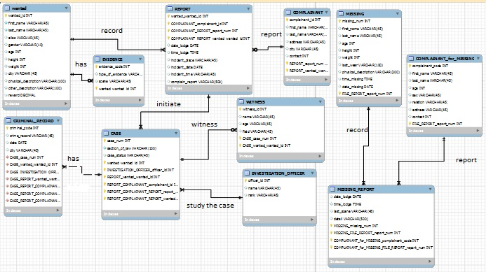

# Data Dictionary

WANTED RECORD

WANTED

|  |  |  |  |  |  |  |
| --- | --- | --- | --- | --- | --- | --- |
| attribute | content | type | format | required | PK | FK |
| wanted_num | Wanted list number | INT | XXXXX | Y | PK | FK |
| fname | Wanted first name | VARCHAR | XXXXX | Y |  |  |
| lname | Wanted last name | VARCHAR | XXXXX | Y |  |  |
| alias | Other name of a wanted | VARCHAR | XXXXX |  |  |  |
| gender | Wanted’s gender | VARCHAR | XXXXX |  |  |  |
| age | Age of wanted | INT | XXXXX |  |  |  |
| height | Wanted’s height | INT | XXXXX |  |  |  |
| weight | Wanted’s weight | INT | XXXXX |  |  |  |
| city | City of wanted | VARCHAR | XXXXX |  |  |  |
| phys_descript | Physical description | VARCHAR | XXXXX | Y |  |  |
| other_descript | Other description | VARCHAR | XXXXX | Y |  |  |
| reward | Reward of wanted | DECIMAL | XXX,XXX,XXX |  |  |  |

REPORT

|  |  |  |  |  |  |  |
| --- | --- | --- | --- | --- | --- | --- |
| attribute | content | type | format | required | PK | FK |
| report_num | Number of report | INT | XXXXX | Y | PK |  |
| date_lodge | Date of lodge | DATE | mm/dd/yy | Y |  |  |
| time_lodge | Time of lodge | TIME | hh:mm:ss | Y |  |  |
| incident_place | Place of incident | VARCHAR | XXXXX | Y |  |  |
| incident_date | Date of incident | DATE | mm/dd/yy | Y |  |  |
| incident_time | Time of incident | TIME | hh:mm:ss | Y |  |  |
| complain_report | Complain report | VARCHAR | XXXXX | Y |  |  |
| complainant_num | number of complainant | INT | XXXXX |  |  | FK |

COMPLAINANT

|  |  |  |  |  |  |  |
| --- | --- | --- | --- | --- | --- | --- |
| attribute | content | type | format | required | PK | FK |
| complainant_num | Complainant’s number | INT | XXXXX | Y | PK | FK |
| fname | Complainant first name | VARCHAR | XXXXX | Y |  |  |
| lname | Complainant last name | VARCHAR | XXXXX | Y |  |  |
| address | Address of complainant | VARCHAR | XXXXX |  |  |  |
| city | City of complainant | VARCHAR | XXXXX |  |  |  |
| contact | Contact of complainant | INT | XXXXX | Y |  |  |

CASE

|  |  |  |  |  |  |  |
| --- | --- | --- | --- | --- | --- | --- |
| attribute | content | type | format | required | PK | FK |
| case_num | Case number | INT | XXXXX | Y | PK |  |
| section_of_law | Section of law | VARCHAR | XXXXX |  |  |  |
| case_status | Status of case | VARCHAR | XXXXX |  |  |  |

CRIMINAL RECORD

|  |  |  |  |  |  |  |
| --- | --- | --- | --- | --- | --- | --- |
| attribute | content | type | format | required | PK | FK |
| criminal_code | Criminal code | INT | XXXXX | Y | PK |  |
| crime_record | Records of crime | VARCHAR | XXXXX | Y |  |  |
| date | Date of record | DATE | Mm/dd/yy | Y |  |  |
| city | City | VARCHAR | XXXXX |  |  |  |

WITNESS

|  |  |  |  |  |  |  |
| --- | --- | --- | --- | --- | --- | --- |
| attribute | content | type | format | required | PK | FK |
| witness_num | Witness number | INT | XXXXX | Y | PK |  |
| name | Name of witness | VARCHAR | XXXXX |  |  |  |
| age | Age of witness | VARCHAR | XXXXX |  |  |  |
| field | Field of witness | VARCHAR | XXXXX |  |  |  |

INVESTIGATION OFFICER

|  |  |  |  |  |  |  |
| --- | --- | --- | --- | --- | --- | --- |
| attribute | content | type | format | required | PK | FK |
| officer_id | Officer’s ID | INT | XXXXX | Y | PK |  |
| name | Name of officer in charge | VARCHAR | XXXXX | Y |  |  |
| rank | Officer’s rank | VARCHAR | XXXXX |  |  |  |

EVIDENCE

|  |  |  |  |  |  |  |
| --- | --- | --- | --- | --- | --- | --- |
| attribute | content | type | format | required | PK | FK |
| evidence_code | Evidence’s code | INT | XXXXX | Y | PK |  |
| type of evidence | Types of evidence | VARCHAR | XXXXX |  |  |  |
| scene | Scene of evidence | VARCHAR | XXXXX | Y |  |  |

MISSING RECORD

MISSING

|  |  |  |  |  |  |  |
| --- | --- | --- | --- | --- | --- | --- |
| attribute | content | type | format | required | PK | FK |
| missing_num | Missing’s number | INT | XXXXX | Y | PK |  |
| fname | missing first name | VARCHAR | XXXXX | Y |  |  |
| lname | Missing last name | VARCHAR | XXXXX | Y |  |  |
| age | Missing age | INT | XXXXX | Y |  |  |
| height | Missing height | INT | XXXXX | Y |  |  |
| weight | Missing weight | INT | XXXXX | Y |  |  |
| last_wear | Missing last wear | VARCHAR | XXXXX |  |  |  |
| physical_description | Physical description of missing person | VARCHAR | XXXXX | Y |  |  |
| time_missing | Time missing | TIME | Hh/mm/ss | Y |  |  |
| date_missing | Date missing | DATE | Mm/dd/yy | Y |  |  |

COMPLAINANT FOR MISSING

|  |  |  |  |  |  |  |
| --- | --- | --- | --- | --- | --- | --- |
| attribute | content | type | format | required | PK | FK |
| complainant_code | Complainant’s code | INT | XXXXX | Y | PK |  |
| fname | First name of complainant | VARCHAR | XXXXX | Y |  |  |
| lname | Last name of complainant | VARCHAR | XXXXX | Y |  |  |
| age | Age of complainant | INT | XX |  |  |  |
| sex | Gender of complainant | VARCHAR | XXXXX |  |  |  |
| relation | Relation of complainant in missing person | VARCHAR | XXXXX | Y |  |  |
| address | Address of complainant | VARCHAR | XXXXX | Y |  |  |
| contact | Contact of complainant | INT | XXXXX | Y |  |  |

MISSING REPORT

|  |  |  |  |  |  |  |
| --- | --- | --- | --- | --- | --- | --- |
| attribute | content | type | format | required | PK | FK |
| date_lodge | Date of lodge | DATE | Mm/dd/yy | Y |  |  |
| time_lodge | Time of lodge | TIME | Hh/mm/ss | Y |  |  |
| last_scene | Last scene | VARCHAR | XXXXX | Y |  |  |
| detail | Detail report | VARCHAR | XXXXX | Y |  |  |
| missing_num | Missing number | INT | XXXXX | Y |  | FK |
| complainant_code | Complainant’s code | INT | XXXXX | Y |  | FK |

# UML Diagrams

1. **Activity Diagram  
   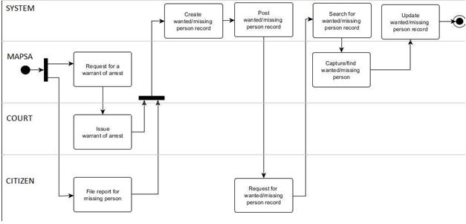**
2. **Class Diagram**

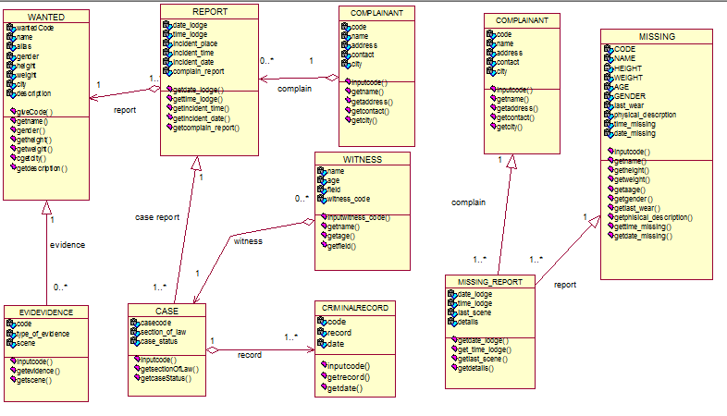

1. **Communication Diagram**

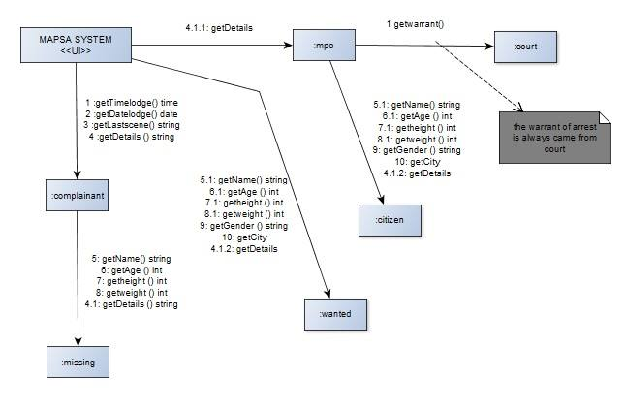

1. **Component Diagram  
   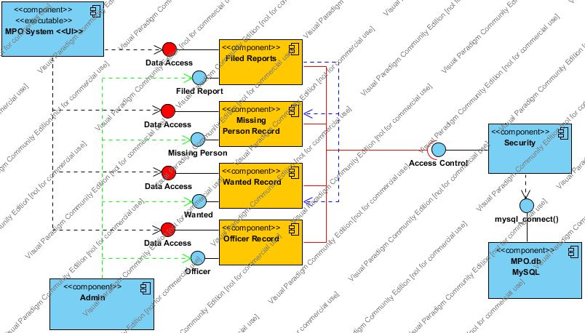**
2. **Composite Structure Diagram**

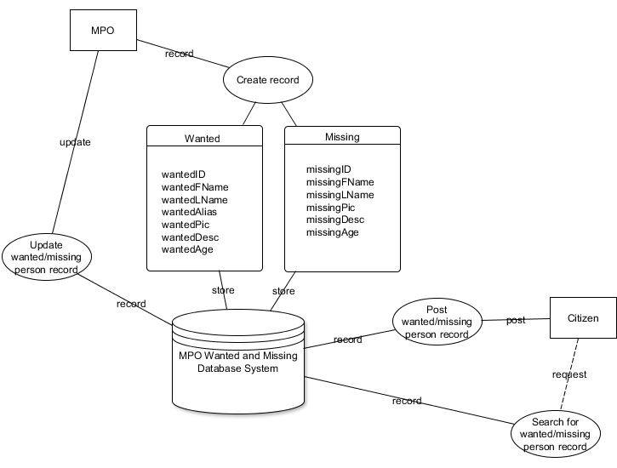

1. **Deployment Diagram  
   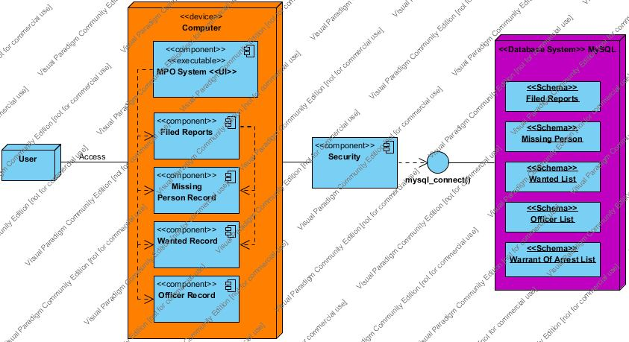**
2. **Interaction Overview Diagram  
   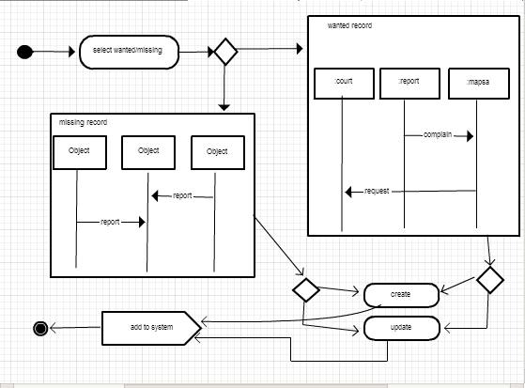**
3. **Object Diagram  
   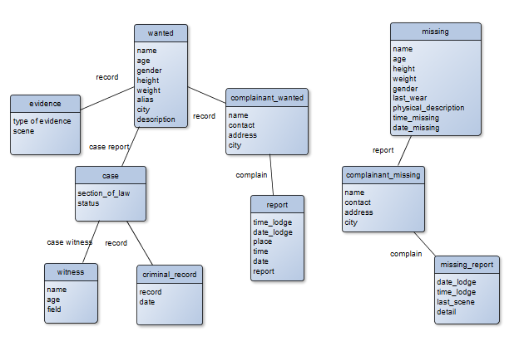**
4. **Package Diagram  
   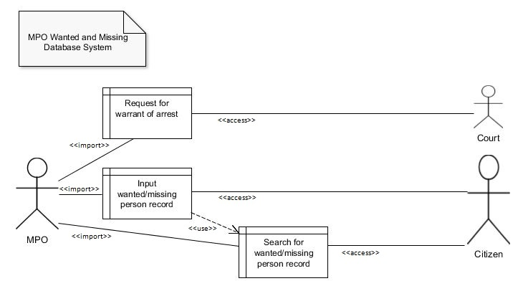**
5. **Sequence Diagram**

**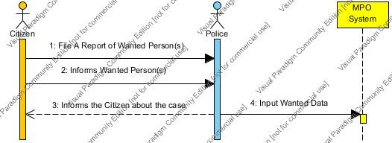  
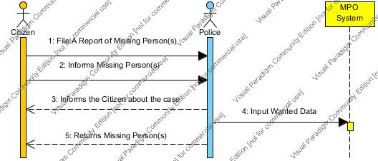**

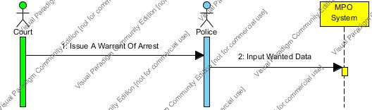

1. **State Machine Diagram  
   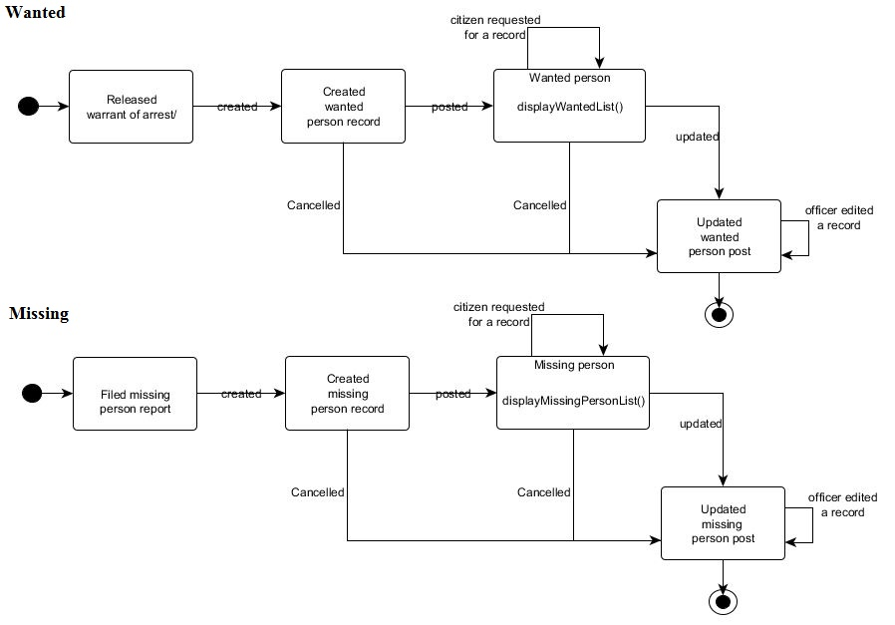**
2. **Timing Diagram  
   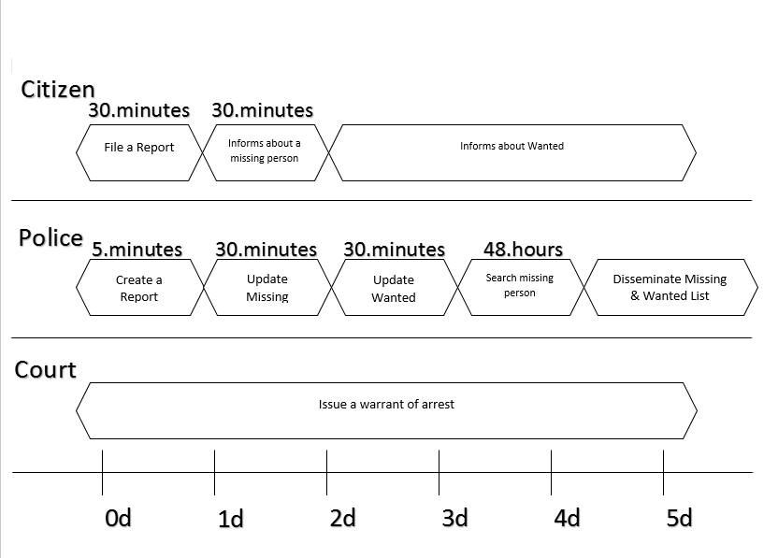**

# Design

